

Computer Games Development CW208

Software Functional Specification

Year IV

Dialogue Tale – A Dialogue Editor and Dialogue System for Unity with a VR example

**[Dawid Jerdonek]**

**[C00247646]**

**[24/04/2023]**

Submitted to the Department of Computing

in partial fulfillment of the requirements for the degree of

Bachelor of Science in Games Development

at the

South East Technological University

May 2023

© South East Technological University 2023. All rights reserved.

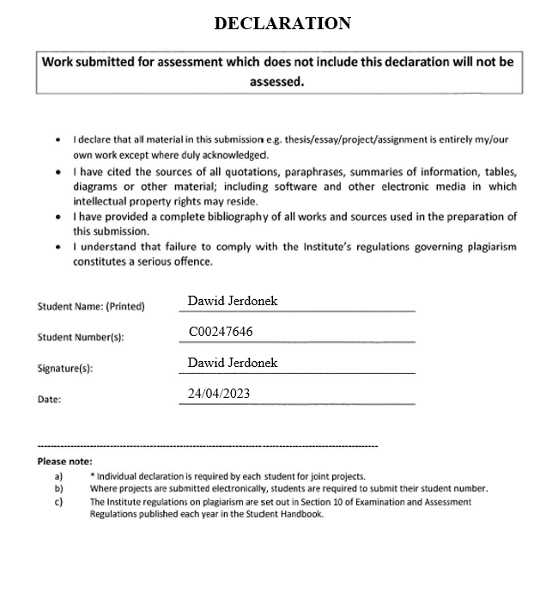

Contents

Acknowledgements 3

Functional Specification 3

References 10

# Acknowledgements

I would like to thank the following people who assisted in completing this project including;

My Project Supervisor Noel O’Hara.

All the 4th Year Games Development Lecturers at South-East Technological University Carlow which have provided crucial feedback, remarks, and criticism.

# Functional Specification

**Target Users**

The target demographic for this project are people that wish to write dialogue for their games but do not know how to begin and how the integration would work. It is also a perfect tool for writers that do not know how to syntax text to be correctly used by Unity. The project eliminates all the complex writing that a user would have to do and instead the user can fully focus on the creation of dialogue in a satisfying, visual space within the “Dialogue Tale” Dialogue Editor.

**Major Functionalities**

Dialogue System utilised all the other components of this project and combines them together into a neat package while handling dialogue dynamically between unique characters. The Dialogue System uses the lists created by the Parser to assign dialogues to corresponding characters with the use of Unity tags. The Dialogue system also loads the different dialogues from storage and runs them through the Parser. This allows the Dialogue system to easily use all of the edited dialogues, which were altered with the Dialogue Editor.

The XML Parser supplies another major functionality of this project. The Parser allows the project to load in XML files containing vital dialogue, it then parses the file getting rid of syntax and assigning lines from the file to the correct corresponding dialogue variables, building the dialogue trees for different characters. The XML Parser allows the Dialogue System and the Dialogue Editor to work correctly and to specification. Without the Parser the project would not be possible at this moment in time.

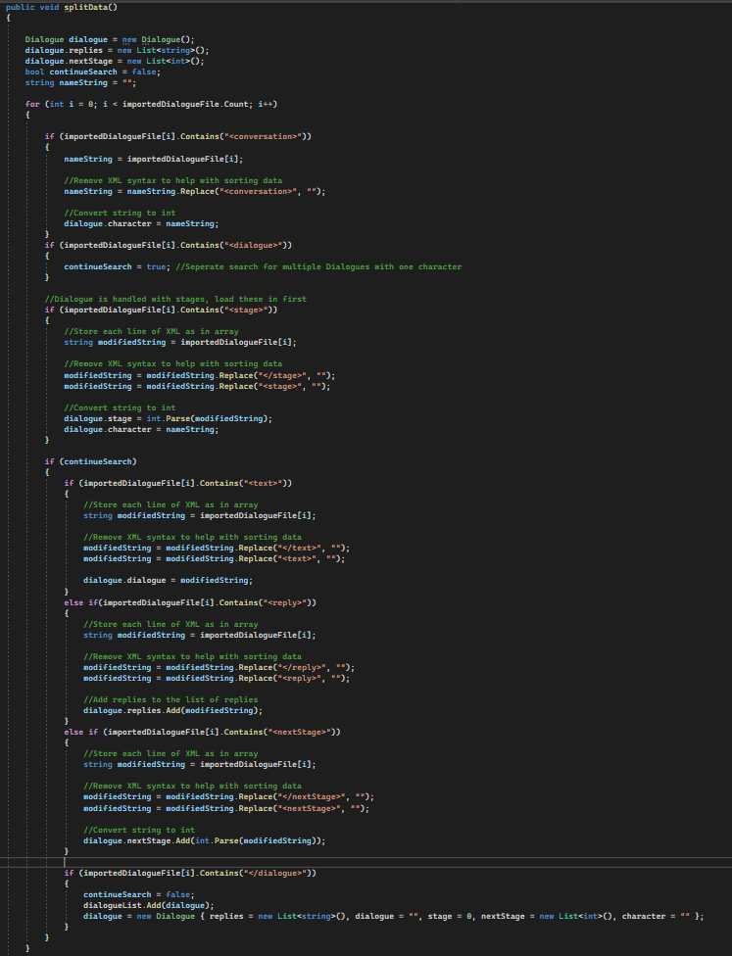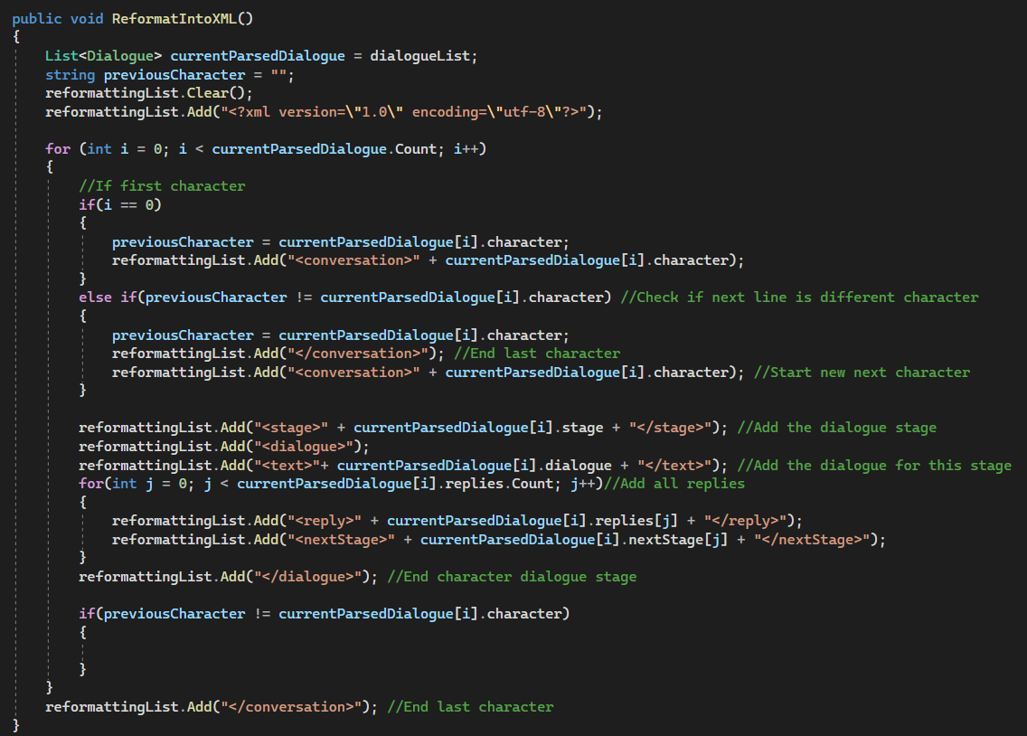

The Dialogue Editor is the next major feature and is the part of the project that users will spend the majority of their time in. The Editor allows users to customise and alter dialogues to their liking. It is a great tool for writing and editing dialogue for a Unity game.

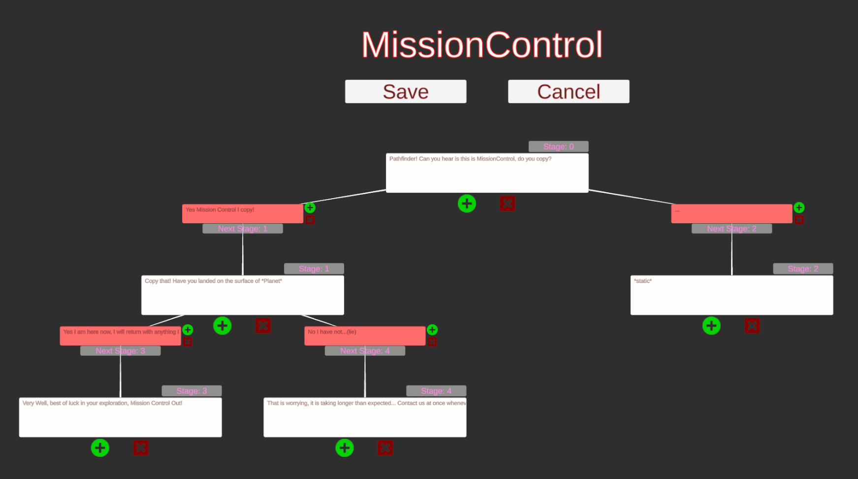

The Maze Generator is the last major complex feature of my project. The Maze Generator generates a procedural maze every time the “Template” scene is started, to create a unique maze every time a user plays the scene.

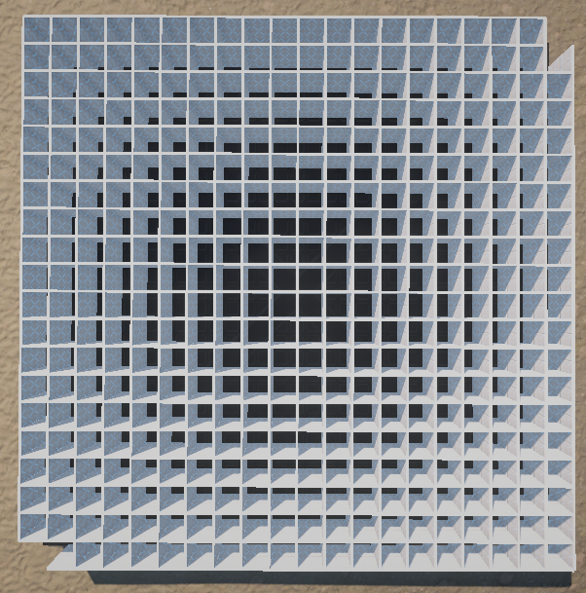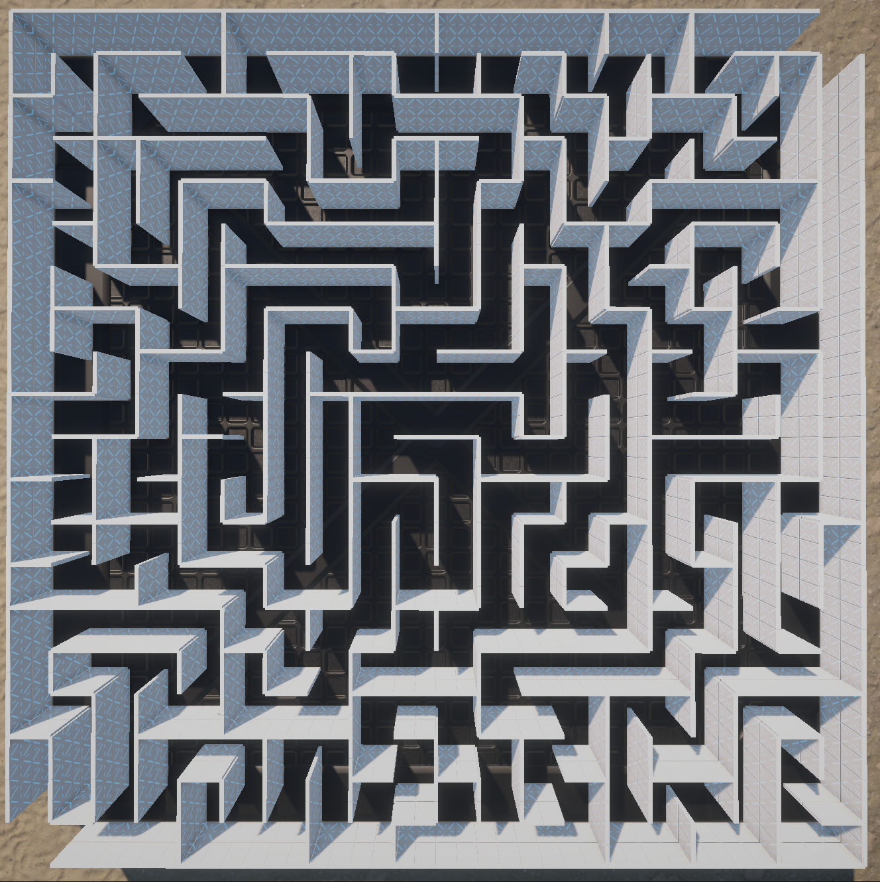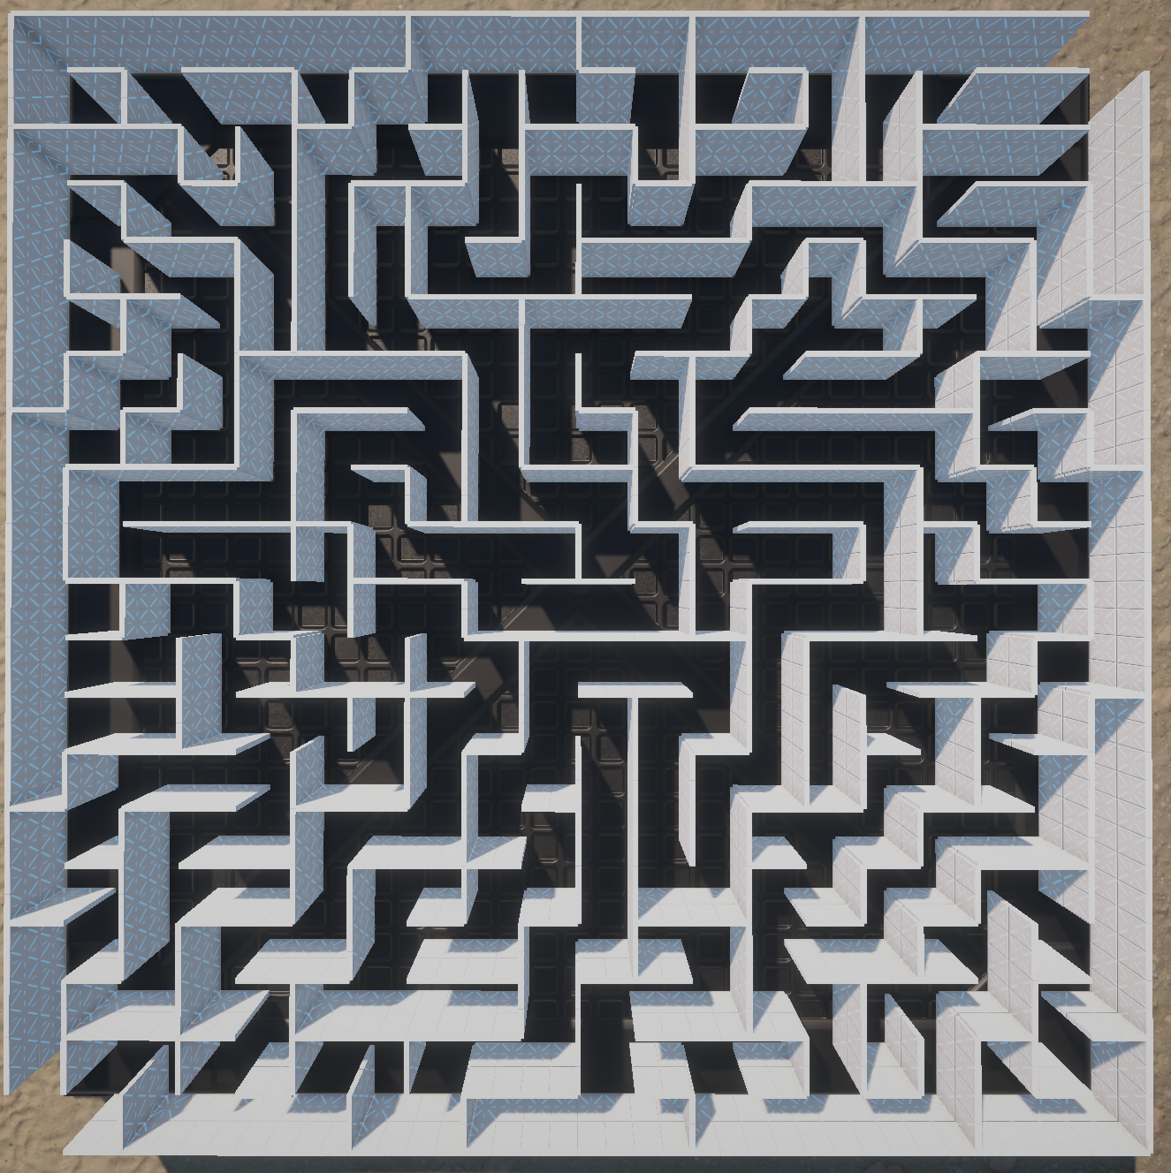

**How is the project used?**

Note: It is recommended that the user has some prior experience with the Unity Engine prior to this

* The project in its entirety is relatively easy to use. To begin a user must download my project onto their computer.
* Once Downloaded the project should be ran ideally through Unity Hub.
* Once the Unity project loads the user should navigate through the project window: Assets > Scenes. From here the user can choose to go into the “Template” scene or the “DialogueEditor” scene.

**If the user wishes to write/edit/delete dialogue:**

* The user should double click the “DialogueEditor” scene and press the play button at the top of the Unity Editor
* The user is then shown the Dialogue Editor view. There are 4 buttons which the user can choose from at the top of the screen. Load Dialogue File, Edit Character, Create Character, Save Current Dialogue.
* If the user chooses “Load Dialogue File” new options will show up on-screen allowing the user to choose which dialogue file, they wish to load or they can cancel the operation.
* If the user chooses “Edit Character” the user will see all the characters that have dialogue in the current loaded dialogue file, appear in the Dialogue Editor window. The user can choose which character they wish to work on by clicking the character name. Once a character name is clicked the Editor will display the character dialogue tree.
  + The character tree on display will consist of several Dialogue Nodes and Reply Nodes depending on how much dialogue is currently written for the character. All the nodes are connected via lines to showcase the possible branching pathways in a dialogue.
  + There are two buttons under each dialogue node and beside each Reply Node. The red X button deletes the given node whereas the green + button creates a new node which will stem from the node on which the button was pressed.
  + To temporarily save this character dialogue the user can press save at the top of the dialogue tree.
  + To cancel all changes to the dialogue tree the user can just press cancel.
  + Once the user is happy with all changes made to characters, to save the new dialogues to file the user simply needs to press “Save Current File” and choose which file they want to save to.
* If the user chooses “Create Character” the user is prompted to type in a character name. The user can then click “Add Character” or “Cancel”.
  + If the user clicks “Add Character” the character is added to the dialogue list and will now show up in the list of characters when the user clicks “Edit Character”. The new character dialogue can now be written.
  + If the user clicks “Cancel” the character is not created.
* If the user chooses “Save Current Dialogue” the user will be shown the options to save to and a cancel button. If the user clicks one of the save buttons the dialogue will be saved to disk in the corresponding XML dialogue file.

**If the user wants to test the template or previously written dialogue with the use of the built in Dialogue System:**

* The user can Use Virtual Reality to play through the scene or simply move the player in Scene View while watching the game view to see the current dialogue displayed by a character. The dialogue displays if the player is close enough to the character.

**User Interface**

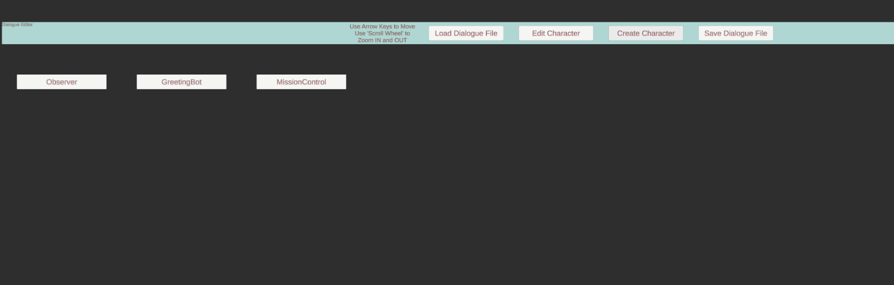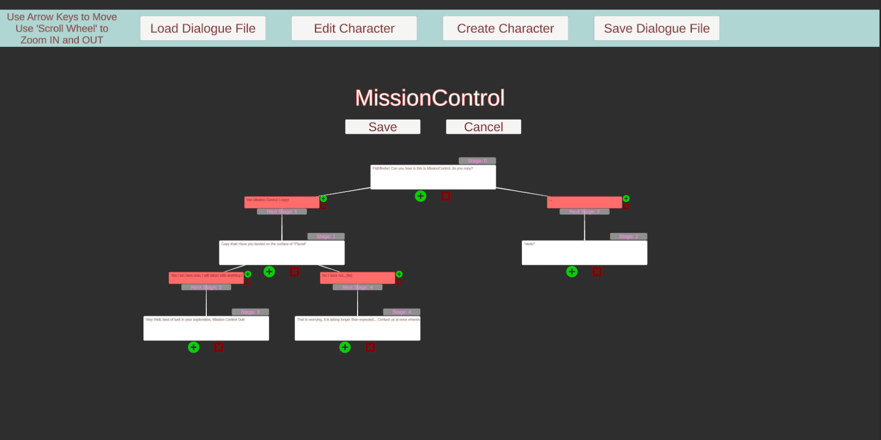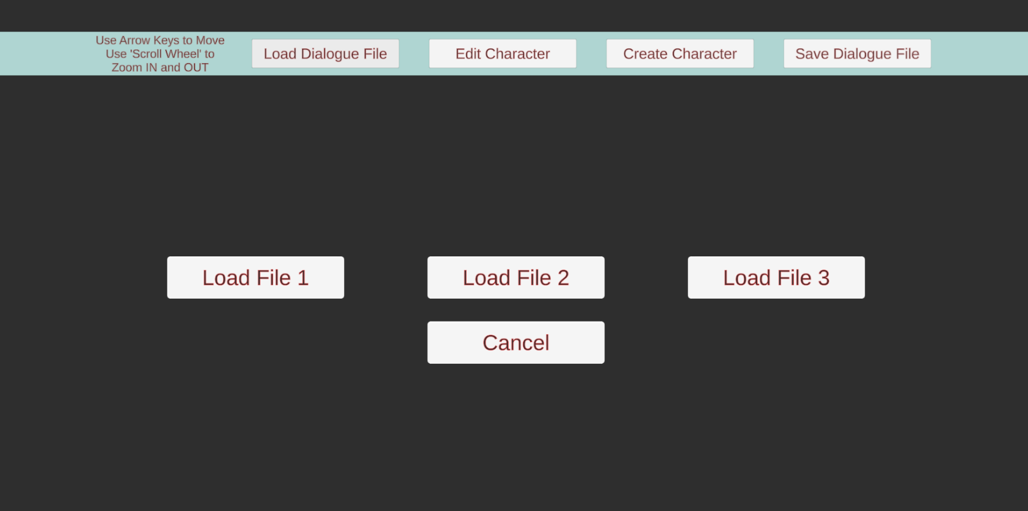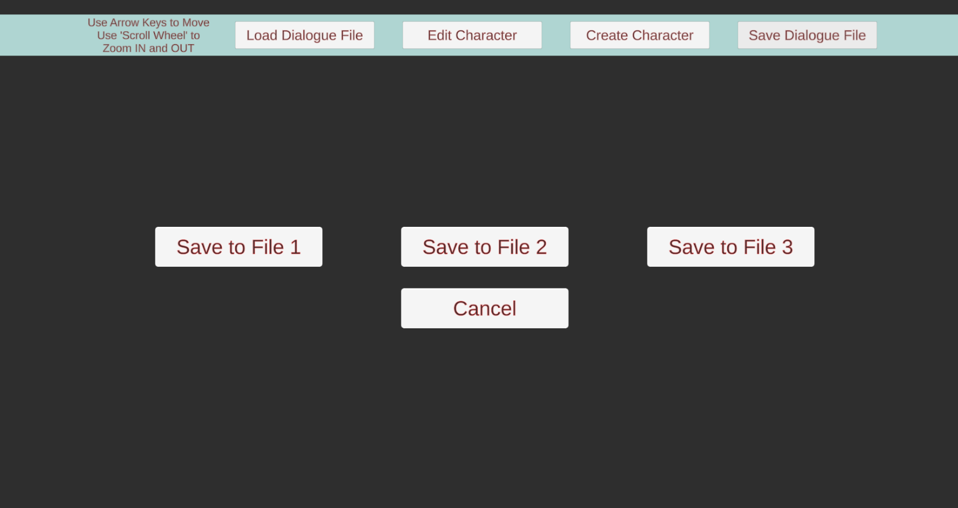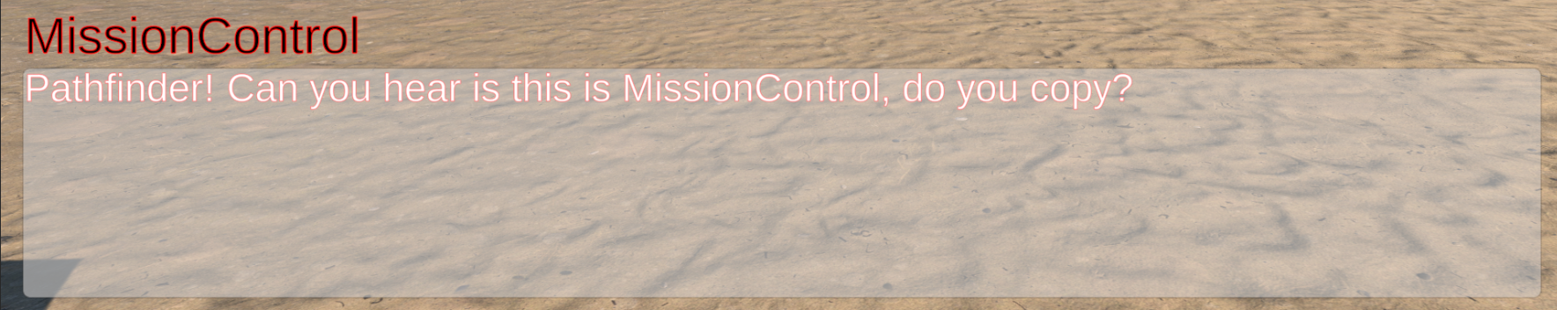

# References

**Books**

Millington, I. (2019) “Chapter 8: Procedural Content Generation,” in AI for games, Third edition. Boca Raton, Florida: CRC Press, pp. 705–726.

**Articles**

Mikkelson, N. (2020) *Game Writing: Structuring Branching Dialogue*, Indie Writing. Available at: https://indiegamewriting.com/writing-1-structuring-branching-dialogue/ (Accessed: January 10, 2023).

Merdivan, E. *et al.* (2019) *Dialogue Systems for Intelligent Human Computer Interactions*, *Science Direct*. Available at: https://www.sciencedirect.com/science/article/pii/S1571066119300106?via%3Dihub (Accessed: January 11, 2023).

Liemhetcharat, A. (2021) *Unity: Reading external XML files*, *GitConnected*. Level Up Coding. Available at: https://levelup.gitconnected.com/unity-reading-external-xml-files-ed199df66288 (Accessed: January 25, 2023).

Philipp, M. (2015) “How To Read An XML File In Unity,” Studica, 15 December. Available at: https://blog.studica.com/read-xml-file-in-unity (Accessed: January 30, 2023).

**Videos**

Board To Bits Games. (2016) Saving Data in Unity: XML Files, [video online]. Available at: https://www.youtube.com/watch?v=6vl1IYMpwVQ&ab_channel=BoardToBitsGames (Accessed: January 27, 2023).

**Websites**

Grasshop Dev (2020) *Dialogue Editor*, *Unity Asset Store*. Available at: https://assetstore.unity.com/packages/tools/utilities/dialogue-editor-168329 (Accessed: February 10, 2023).

*ChatMapper* (2010) *Chat Mapper AI*. Available at: https://www.chatmapper.com/ (Accessed: February 12, 2023).

*PixelCrushers* (2018) *Dialogue system for unity*, *Pixel Crushers*. Available at: https://www.pixelcrushers.com/dialogue-system/ (Accessed: February 12, 2023).